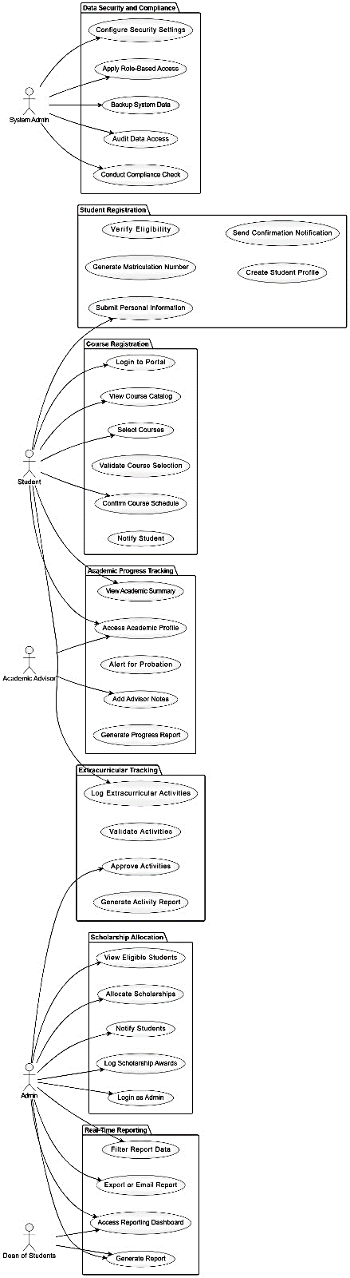

This use case diagram illustrates the functional interactions between different user roles and a university management system. The actors include System Admin, Student, Academic Advisor, Admin, and Dean of Students. Each actor performs specific actions (use cases) grouped under modules like:

• Data Security and Compliance (System Admin)

• Student Registration and Course Registration (Student)

• Academic Progress Tracking (Student & Academic Advisor)

• Extracurricular Tracking (Student & Admin)

• Scholarship Allocation (Admin)

• Real-Time Reporting (Admin & Dean of Students)

The diagram shows how each user interacts with the system to perform tasks such as registration, course selection, scholarship management, and generating reports.

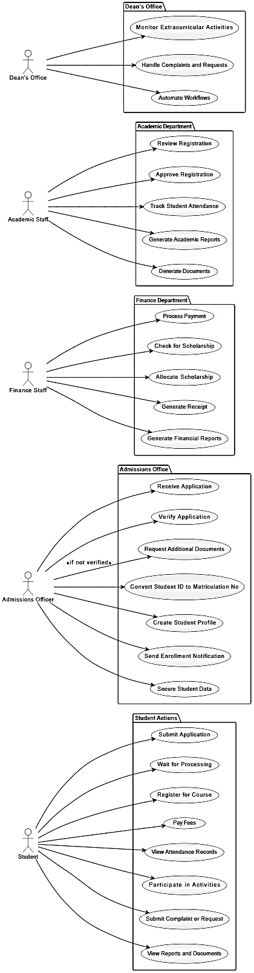

This use case diagram shows the interaction between various university departments and the system. The main actors are Dean’s Office, Academic Staff, Finance Staff, Admissions Officer, and Student. Each actor performs specific roles such as:

• Dean’s Office: Monitors extracurricular activities, handles complaints, and automates workflows.

• Academic Staff: Manages registration, attendance, academic reports, and documents.

• Finance Staff: Handles payments, scholarships, and financial reporting.

• Admissions Officer: Manages student applications, verification, and profile creation.

• Student: Engages in application, registration, payments, activities, and accessing reports.

The diagram defines how these roles contribute to the student lifecycle within the academic system.